**DRIED SILAGE**

A Market Research Presented To The Faculty of

SORSOGON STATE UNIVERSITY

BULAN CAMPUS

BULAN SORSOGON

In Partial Fulfilment For The Degree

Bachelor of Science in Entrepreneurship

Proponents:

Amor Johnzel B.

Agne Jomel A.

Gavarra Salvacion C.

Habla Antonette H.

Gloriane Delmonte

Subject Professor

**TABLE OF CONTENT**

**TITLE PAGE**

**TABLE OF CONTENTS**

1. BUSINESS PROFILE
2. General Description of the Business Rationale
3. Industry Background
4. Goals and Potential Notes
5. MARKETING PLAN
6. Product Description
7. Market Description
8. Distribution Strategy
9. Target Market
10. Market Gap
11. Production/ Operations Plan
12. The Product
13. Production Process
14. Cost of Product
15. Physical Resources, Facilities and Equipment
16. Management
17. Organizational Chart

1. Job Description
2. Related Literature

Curriculum Vitae

1. **BUSINESS PROFILE**
2. **General Description of Business Rationale**
3. **Industry Background**
4. **Goals and Potential Notes**

1. **MARKETING PLAN**

**A. Product Description**

The product Dried silage is mainly made of fresh silage fish also known as silver veloori fish. Silver veloori fish is a type of seafood that is commonly found in the Philippines. This fish contains many nutritional values including omega 3, fatty acid and protein that are essential and beneficial for human health.

The silage fish go through deboning process that makes it more crunchier and convenient when consumed. To maintain the quality of the product we used surgical scissor to avoid the fish from damaging. The fish is cut in a butterfly style to make it more attractive and pleasing to the eyes of the consumers, and it also helps the fish to absorbe the flavorings faster when marinated.

The fish is marinated in vinegar solution for 30 minutes with salt, garlic, ginger and monosodium glutamate that enhances the flavor of the silage before undergoing sun drying process.The sun drying process takes 2 to 3 days under direct sunlight for it to diminish the moisture of the fish that helps to lessen the possibilities of contamination and gives longer storage life.

Dried silage only takes 30 to 60 seconds to be cooked, it has a golden brown color when fried and does not have a strong smell of fishiness on it, perfect to partner in rice or drinks and even consumed the product itself.

1. **Market Description**
2. **Distribution Strategy**
3. **Target Market**

One of the main dish in Philippines cuisine is (Tuyo) or dried fish. Many Filipinos (Pinoy) loves eating dried fish because it is easier to cook and also cheaper in price specially in times wherein fresh fish is difficult to catch. The love for dried fish has no age even children really like it. most of the high School students, college and working individual age 10 to 64 prefer to cook and eat dried fish because of cheap in price and easier to cook specially if they are in hurry to school and works. people age 10 above are more likely skilled in cooking and knowledgeable of budgeting and does people from 64 above is more likely prone to complication and allergies that sensitive in food intakes.

That’s why one of the perfect target market are does in age range of 10 to 64 years old. the geographic location of the target market is the Sorsogon province that has a total of 16 municipality which is the Bacon, Barcelona, Bulan, Bulusan, Casiguran, Castillia, Donsol, Gubat, Irosin, Juban, Magallanes, Matnog, Pilar, Prieto Diaz, Sorsogon, Sta. Magdalena.

From the latest census of year 2020 the total papulation of Sorsogon province is 828,655 and the target market of us are the 71.33% or a total of 565,621 of the papulation of Sorsogon province.

Table 1: SWOT ANALYSIS

|  |  |
| --- | --- |
| STRENGHTS | WEAKNESS |
| - New flavors that will interest the consumers.  - Affordable price with best quality  - well organized organization | - No customers loyalty yet  - unstable price of raw materials  - existing competition from well-known producers and establishments. |
| OPPORTUNITIES | THREATS |
| - Export quality products  -increase numbers of potential customers  - improved marketing and advertising strategy using social media flat forms to connect with customers.  - Training for staff and additional workers | - Big numbers of target market is engage with other food products  - Reputation as a newly stablish business  - Strong competition with other existing business  - Possible imitators |

**E. Market Gap**

Based on microbial, Physicochemical and Sensory Quality Evaluations of salted herring subjected to different drying processes by Alonzo A. Gabriel and Alexie S. Alano-Budiao of food science and technology, they said that dried fish is part of the Filipino diets, not only because of its cheap price and health benefits, it was also the main livelihood of people specially does near-shore. Despite of being common dish in the Philippine the demand for dried fish is still high because of its long storage life and addicting taste.

But consumers are always looking for more, something interesting and unique. that’s why this newly innovated product of dried silage will surely hook up the intertest and taste preference of people who love dried fish. The product is offered in new flavors like vinegar and spicy vinegar.

This new version of dried silage is boneless that uses surgical scissor in processing to insure that the quality and looks of the product is maintained. From processing and packaging the product can compete with other existing dried fishes offered in the market and this is a big opportunity for the future of the business.

despite of offering high quality product the company will insure to distribute affordable products for consumers, to gain their loyalty and patronage for the product for us to increase potential consumers.

with the use of modern technology the advertisement and promotion of product will become very convenient and effective comparing to traditional and common way of advertisement, through this the scope of market will also widen.

additional staff and workers are needed for large amount of production, training and program will help the staff to become a skilled workers and this will lead to more organize business that also offers opportunity for new works.

1. **Production/ Operations Plan**
2. **The Product**
3. **Production Process Procedures**

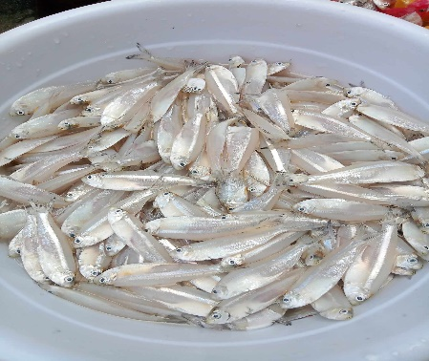

**Step1-** prepare the fresh silage fish and wash in clean water

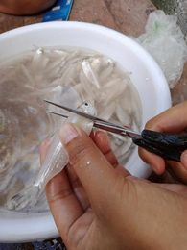

**Step 2**- cut the head and tail of the fish using the surgical scissor.

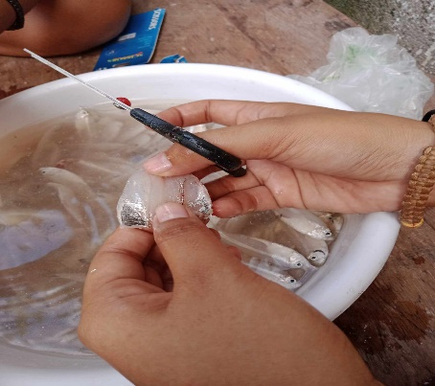

**Step 3-** butterfly cut the fish

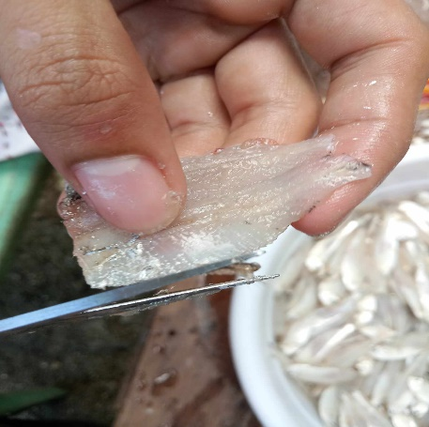

**Step 4**- Carefully removed the bones of the fish

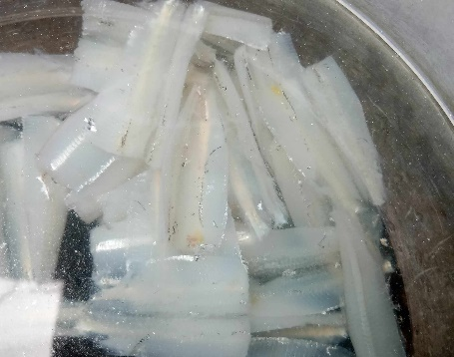

**Step 5**- transfer the deboned fish in basin and wash again to remove the remain blood.

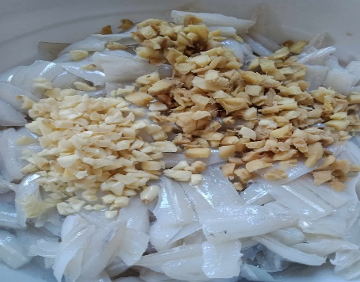

**Step 6**- prepare the fish for marinating process. using vinegar, salt , MSG, ginger and garlic.

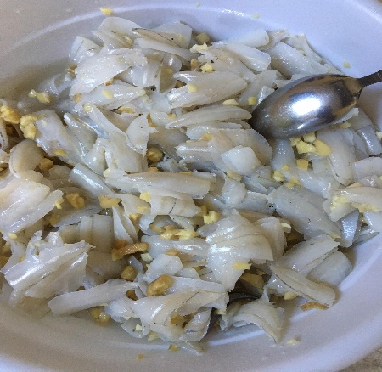

**Step 7**- set aside the fish for 30 minutes to absorb the flavors

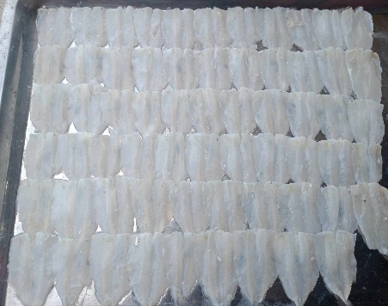

**Step 8**- after marinating, place the marinated fish in tray and prepare for sun drying

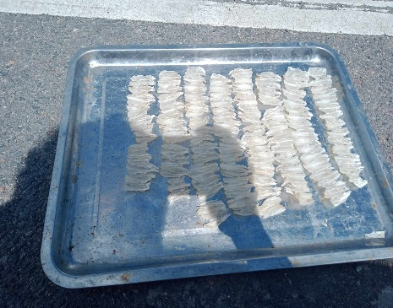

**Step 10**- place the fish under direct sunlight

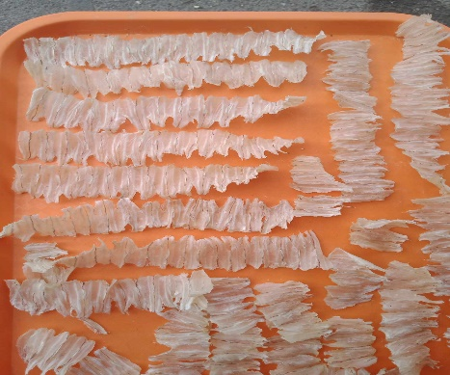

**Step 11**- after 2 to 3 days of sun drying process, check for the quality of fish and remove

defected pieces.

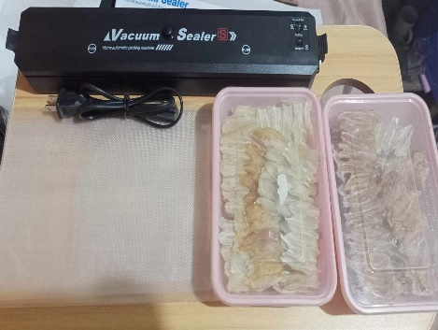

**Step 12**- prepare the finish product for packaging

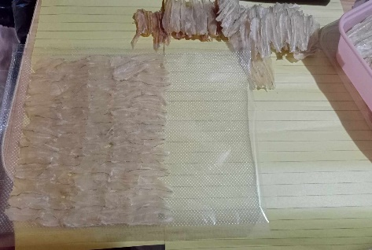

**Step 13-** place the dried silage inside the vacuum bag

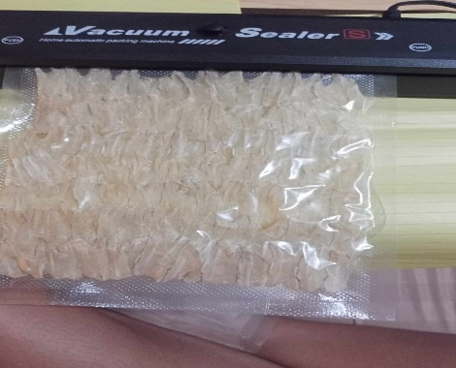

**Step 14-** vacuum sealed the bag

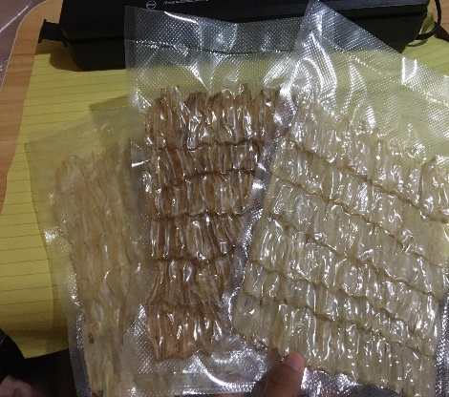

**Step 15**- Ready for Selling

1. **Cost of Product**
2. **Physical Resources, Facilities and Equipment**

The physical resources are veloori fish (Silag), white vinegar, MSG, salt, garlic, chili and ginger. Most of the stages is performed manually, it also uses measuring tools in the process to maintain the quality and taste of the product. However the

**Ingredients:**

* **Silage fish/veloori fish (silage)**
* **White vinegar**
* **Monosodium glutamate**
* **Salt**
* **Garlic**
* **Ginger**

**Tools and Equipment:**

* **•Surgical scissor**
* **• Basin**
* **• Strainer**
* **• Tray**
* **• Measuring spoons and cup**

1. **Management Plan**
2. **Organizational Chart**

1. **Job Description**
2. **Related Literature**

**Curriculum Vitae**

**B. VMGO**

**VISION**

To become a papular and well known producers of the best dried silage in the country and to give satisfaction and highquality product for an affordable price.

**MISSION**

To serve a nutricious and clean product, unique and delicious dried silage and provide a good quality customer service with care and love.

**GOALS**

* Increase the profit of the business
* Promote locally produce raw materials
* Provide benefits and care for the staff
* Maintain the company productivity
* provide excellent customer service
* produce clean and quality product

**OBJECTIVES**

* used equal measurement and standardized process to maintain the quality and cleanliness of the product.
* show respect and equal treatment to all customers.
* Provide the basics benefits of the staff to maintain good relationship and productivity.
* use locally produced raw material to promote local

**C. Resources**

The Philippines is rich in many resources specially when it comes to seafoods due to geological location of our country. Our country produces many varieties of fish and one of those is the silage or silver veloori fish.

In municipality of Bulan, Sorsogon silage or veloori fish catching season start from the month of September to November and after that the fish changes their location and can be found in other places of Sorsogon province, like in municipality of casiguran that is also available in their from the month of October, November, December and from March to May. Despite of changes in location of veloorie fish the presence of the fish does not vanish totally but only limited in numbers and size.

When it comes to supplier of raw materials for the product speacially in silage or viloore fish one of the effective ways to establish good and loyal supplier is to offer them a good price that will benefits both parties. Another one is to have a good relationship and communication with the supplier.

our ideal supplier are does fisher man that mainly catch silage or veloori fish and also does places where the fish is being brought for dealing transactions like fish forts.

**D. Competition**

The market offers different kinds of viand for consumptions from raw to easy to cook products, but most of the consumers demanded for something that is nutritious, affordable and at the same time can be easily prepared. That’s why dried fish is the perfect choice for everyone. Typically an ordenary dried fish is offered in salted flavor and already available in many market places. But consumers get easily uninterested of it due to salty taste.

That is why we offered new product that will hook up the interest of our target consumers. Which is the dried silage or veloori fish not only salted but also available in vinegar and spicy flavor. In additional it is high quality product that undergo deboning for convenient and better consumption. These qualities make the product itself unique among other kinds of dried fish.

in the market dried silag has alot of compition and one of the direct competetors of the product is the dried boneless dilis silag of pilar Capiz and other local producers and didtributor in the market here in municipality of bulan. but this new product of dried silag will offer a new flavors and quality that will patronize by many consumers.

**Survey Questioner for Dried Fish Consumption**

Name(optional):

Age:

DIRECTION: put a check / to the answer you have choosen

1. How often do you eat dried fish in a week?

_A. Never

_B. Onece

_C, Twice a week

_D. Every day

2. what kind of dried fish doyou prefer to eat?

_A. boneless

_B. with bones

3. what do you prefer to eat?

_A. Salted dried fish

_B. Vinegar flavor

_C. Spicy Vinegar flavor

5. Reason for eating dried fish

_A. Favorite

_B Cheap in price

_C.Nutritional Value

_D Easy to cook

Other reason_____________

6. How many kilo gram of dried fish you are buying everytime?

_A 1/8 KG

_B 1/4 KG

_C 1/2 kG

_D. i KG

Other answer_________